**JQuery Animated Slider**

JQuery Animated Slider has been developed using Bootsrap3. So it is compatible for desktop, iPad, tablet, and phone.

**Following are some of the key points to modify the code without changing the JS file.**

1. **Need to add the extra text in link** – Go to the respective link and add the text inside <p> </p>.

Ex. If I want to add text in link3. Check the following code.

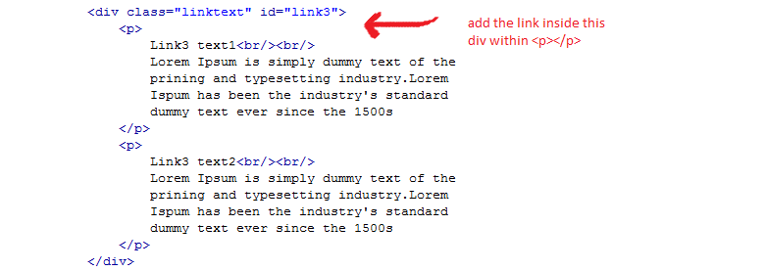

1. **Need to insert extra link Node** – Go to “li” of nav. Add one li with link node name and add respective text in <p></p> as suggested previously.

